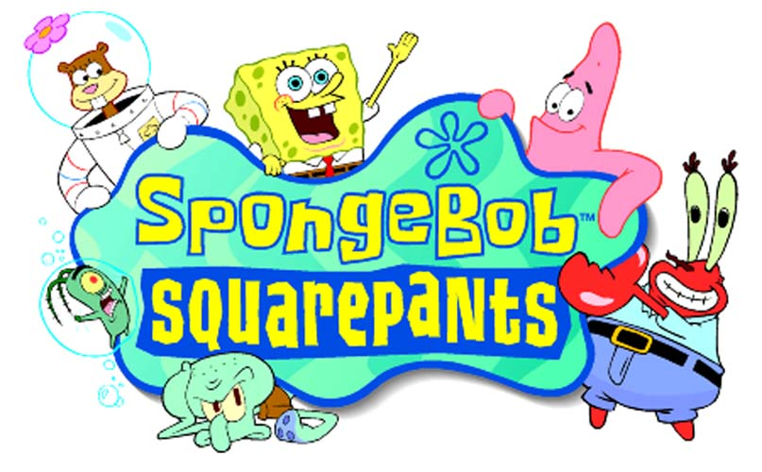

GAME LOGO HERE

MDD

written by
Kevin Martin, Lead Artist

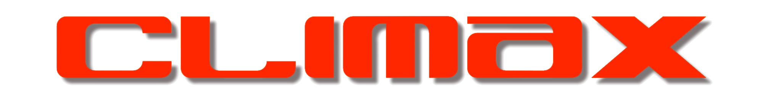

(FAREHAM)

for

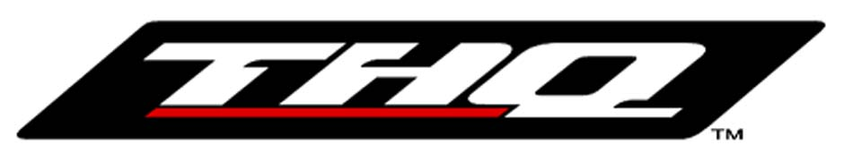
Table of Contents

Overview 3
Format: 3
Media 3
Memory Capacity for Art Data 3
Target Platform 3
Rendering Engine 4
Art Style Guide 5
Art Creation Restrictions (Quick Reference) 6
Using the Map Editor 8
File Name Conventions 10
Directory Structure 10
Version Control 10
Tools 11
“Off-the-Shelf” 11
Proprietary 11
Resources 12
Human Resources 12
Hardware Resources 12
Software Resources 12
Game Engine Restrictions on Art Creation 13
FMV 13
Front End & Menu’s 13
Source and Target Textures 13
Source and Target Models 13
Source and Target Animations 13
Gourading, Environment Maps & Bump Maps 14
In-Game Control Panel & Menu’s 14
Source and Target Textures 14
Source and Target Models 14
Source and Target Animations 14
Gourading, Environment Maps & Bump Maps 14
Environments 14
Proposed Levels 14
Source and Target Textures 15
Source and Target Models 15
Source and Target Animations 16
Gourading, Environment Maps & Bump Maps 16
Characters/Vehicles 16
Source and Target Textures 16
Source and Target Models 16
Source and Target Animations 16
Gourading, Environment Maps & Bump Maps 17
Pickups/Weapons 17
Source and Target Textures 17
Source and Target Models 17
Source and Target Animations 17
Gourading, Environment Maps & Bump Maps 18
Special FX & Particle Systems 18
Source and Target Textures 18
Source and Target Models 18
Source and Target Animations 18
Gourading, Environment Maps & Bump Maps 18
Cameras 18
Lights 18
Shadows 18
Procedural Textures 18
Production Pipelines 19
FMA 19
Front End & Menu’s 19
In Game Control Panel & Menu’s 19
Environments 19
Characters/Vehicles 20
Facial Expressions 20
Guise 21
Pickups/Weapons 22
Special FX & Particle Systems 22

Overview

Format:
Playstation & Gameboy Advance.
This document deals with Playstation only.

Media
CD : available storage – approx 618 Mb.

Memory Capacity for Art Data

Target Platform
The target platform is the Sony PlayStation console with:

(DRAM) MEMORY: |  | 2 MB RAM
(VRAM) MEMORY : |  | 1 MB RAM
SAVE RAM: |  | 0-120 K (developer option)
CD-ROM: |  | Built-in x2 speed
OUTPUT: |  | RF/Composite
INPUT: |  | Standard SONY controller
 |  | SONY Analogue controller

All of the in-game characters will be created as low polygon characters. Non -player characters will be animated in 3D and rendered as sprites, Spongebob will remain a polygonal character in–game.
Previous Climax PSX game engines can comfortably handle 3 Mbs of level data however the style of game and level structure mean that Spongebob levels will be considerably less than this.
Levels will be compiled in a map editor and made up of 2D and 3D tile blocks.

Rendering Engine
Screen resolution is 512 x 256.
Polys will consist of some or all of the following;
Material colour
Textured
Vertex shaded
Target fps 20-30

Art Style Guide

Spongebob Squarepants the cartoon has a very distinct graphical style. It is both the desire of THQ and our own opinion that we remain faithful to this style.

The look of the game will be pseudo 3D, built in 3D but handled like a traditional 2D platformer.

In keeping with the 2D cartoon style textures should be used with a certain amount of discretion relying on material colour and vertex shading to achieve a bold colourful look where possible. The same is also true of characters models.

There will be a shared resource of textures and scene elements across the levels within any one theme so the reusability of artwork should be borne in mind. This will also make recreating artwork on the GBA more achievable.

Platforms (except moving platforms) should be part of their environment e.g. in an aquatic scene they should look organic, a foreground formation belonging to the background. We should aim to utilise the screen for platforming as imaginatively as possible.
Interactive scene objects, pickups and buttons/switches should be consistent and/or have a visual cue e.g. highlighting, outlining, animating.

Art Creation Restrictions (Quick Reference)

The game screen measures 20 tiles high by 30 across.
It consists of 5 layers:
Background 2D
Middle background 2D
Action layer 3D
Foreground (PSX only) 2D
Collision

Spongebob is 4 tiles tall (64 pixels)
2D tiles are 16x16. However the map editor will load a 2D bitmap up to 128x128 and cut them into tiles for you e.g. a 32x32 bitmap will be treated as a group of four 16x16 textures. (This facility is only there to avoid saving multiple bitmaps and should not impact the conservative creation of tiled sections.)
Texture transparency uses pure magenta only – RGB 255, 0, 255.
Magenta should be colour one in the bitmap.

Scenes in Max should be set up with a grid 1m³
3D tiles measure no more than 1x1x8 (8 = depth)
Texture resolution on 3D tiles does not exceed 16x16 pixels on the z x of a single tile. The y may be textured in more detail. (max co-ordinate system)
Texture sizes adhere to 8, 16 or 32 pixels (not necessarily squared)
Bitmaps for use on 3D geometry may be no bigger than 32x32.
E.g. a 32x32 texture may be applied to four separate 3D tiles as long as the texture resolution is not exceeded on an individual tile.
A 3D tile, its material name and texture name should be identical.
The pivot point must be centred on the base of each tile. You may need to reset the transforms before exporting.
Multi sub objects should not contain any materials that do not contain a bitmap.
Map Paths should be stripped and paths configured to VSS texture directory.
Your favourite tools will become the ‘snap to grid points and grid lines’ ‘snap to vertex’ and ‘Move transform type In’ dialogue boxes.
Your favourite tipple will become a double whiskey, straight up.
There is a limit of 800 unique tiles per level to ensure that the levels can be displayed on AGB however you may bear in mind that the AGB will ignore any unique bitmaps we create for the surface of the action layer or the foreground layer.

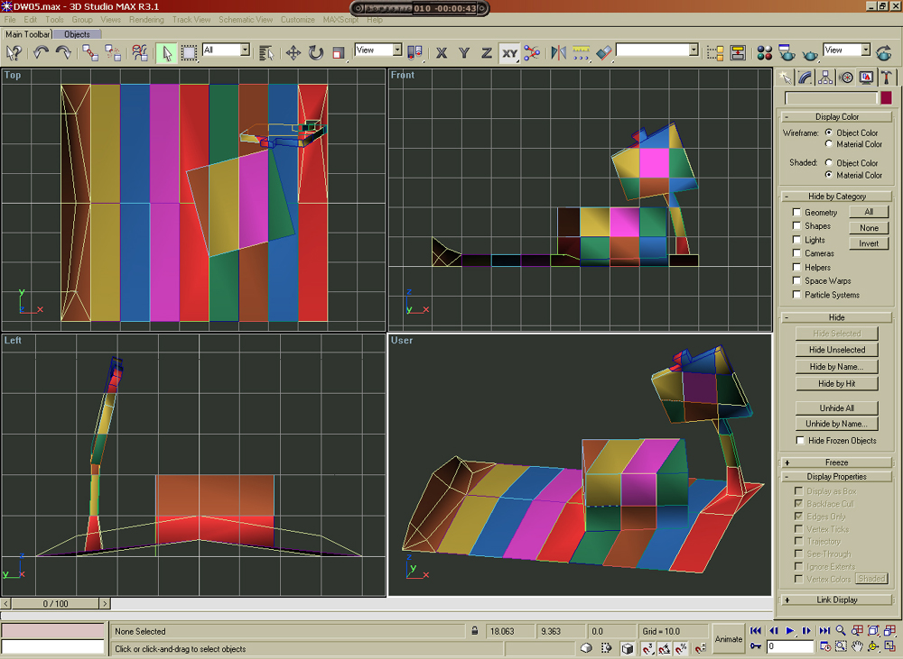

A Tile Set. (untextured for clarity) You will find it easier to texture your tiles before cutting them up and detaching to individual tiles.

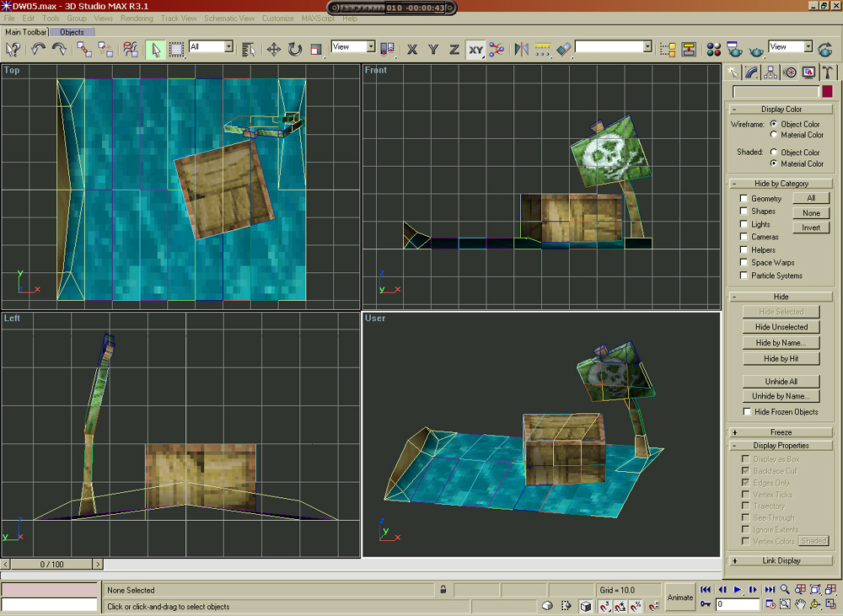

Using the Map Editor

The map editor is split into two sections. Tile load/select and Map/tile placement.
It uses: 2D bitmaps, 3d tiles (exported from Max as .gin files).
Before using the map editor you should check that your directory structure adheres to the following example (folder names are underlined):
Chapter01-
Level02-
.mep (map editor files)
Tiles-
.bmp (2D tiles)
.gin (exported 3D tiles from max)
.max (max scenes)
Textures-
.bmp (max textures)

See graphic below.
- Load tiles.
- Active/Visible layer.
- Tile placement/Copy and Paste Mode toggle.
- Active brush.

Shortcut keys.
Left mouse select tiles in tile screen
Left brush in map screen
Select/ place tiles in copy mode.
Middle mouse Navigate and zoom with mouse wheel.
Right mouse Right brush.
Space Toggle between tile screen and your map.
[ Show left brush
] Show right brush
# 2D/3D toggle
Ctrl fast navigate.
G Grid on/off toggle
Ctrl C Copy
Ctrl V Paste
X Flip tile on the X axis
Y Flip tile on the Y axis

Points to remember:
Keep yourself familiar with everyone else’s work. What you are about to create may already exist in another level.
Your computer should be in True Colour 32 bit mode.
The size of your map can be increased after when required (Map/ Set Size).
There is no undo, save often!
3D tiles will be loaded into the map editor in the order in which they were created.
When in tile select mode drag from top left to bottom right
Make sure you are on the correct layer.
Tiles may be easier to place, copy or paste in 2D mode.
2D tiles may (should) be used on the action layer and will appear at the front of this layer.
Use as much 2D on the action layer as possible to reduce the amount of polys on screen.
The background layer is not an art requirement so please ignore.
After copying a section of your map switch to tile placement mode to better see your selection for pasting.
If your tile does not load check your file in max for outsized tiles, empty materials, map paths/configuration, pivot point placement and orientation, colour depth of your bitmaps.
If you can’t see your problem or you’ve discovered one, mail me.

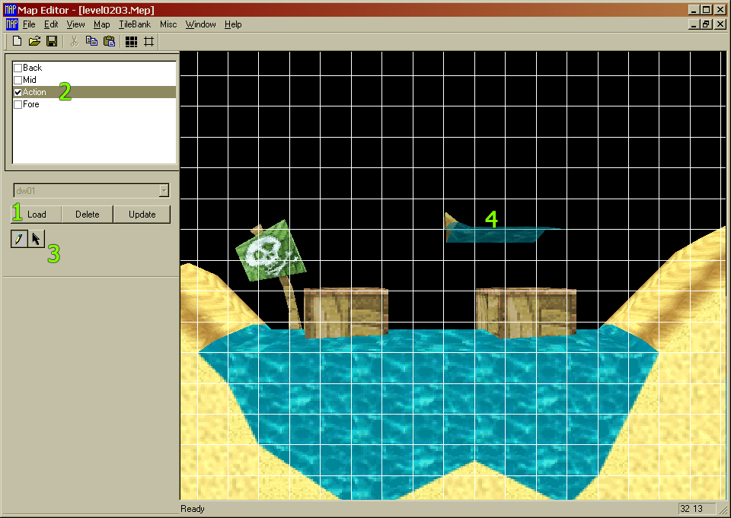

File Name Conventions
Previously used prefixes. To be confirmed.
+ (Use alpha channel)
! (Scroll texture vertically. Must be divisible by 8)
@ (Scroll texture and use alpha channel)

It should be noted that as a matter of good practice all textures and scene objects should carry unique and succinct file names so that artists can, if necessary, easily familiarise themselves with another artists work.

Directory Structure
To be put in place.

Version Control
VSS Version 6.0

Tools

“Off-the-Shelf”
These tools will be detailed later on in the Software Resource Requirements section.

Proprietary
The only notable addition at this stage will be a level editor specific to level creation on Spongebob.

Resources
Art budget?
Project studio plan.

Human Resources
Nick Dry Game Designer
Level Design
Front end Design
Story integration.

Kevin Martin Lead Artist
Characters, Levels.

Rob Wilmot Artist
Levels.

Nigel Apperley Animator
Character animation.

N.B. There will also be a shared art resource between the GBA and playstation versions.

Hardware Resources
A second development kit is the only outstanding requirement, however it is not essential to the project at this time.

Software Resources
3D Studio Max. v3.1 x4
Character Studio v2.2 x2
Adobe Photoshop v.5.5 x3
P2 x3
Dpaint x3
Level Editor (In house) x3
UV Botherer (In house) x3

Game Engine Restrictions on Art Creation

FMV
Not Applicable. We will be using FMA as a link between themed areas to inform the player about their gameplay objectives. For further information see Production Pipelines.

Front End & Menu’s
THQ logo
Spongebob logo
To be supplied by THQ:
Legal screen text.
Speech for game designers script.

Source and Target Textures
4 Bit textures with palette sharing used when possible.

Choice of fonts to be decided.

All art data must adhere to the Spongebob cartoon. Any artist can refer to the resource directory which acts as an ample style guide.
THQ will be supplying resource material directly from Nickelodeon consisting of background cells and animation cells for Spongebob characters. All menus and controller set up screens should be comprehensible to children. Navigation through setup and option screens should be straightforward and all icons/fonts should be easily recognisable/legible.
All logos must be consistent with those of the manufacturer, license etc.

Source and Target Models
The front end will primarily consist of 2D layers although some 3D text may be used. The Spongebob opening credits will act as a reference for fonts and background visuals.

Source and Target Animations
Front end animations will be limited to animated text and screen swipes.

Gourading, Environment Maps & Bump Maps
Vertex Lighting.

In-Game Control Panel & Menu’s
These will be kept to a minimum:
Spongebobs health status*
Number of lives*
Current ammo (related to current skill item).

*Appears on screen when Spongebob is hurt or loses a life.

Source and Target Textures
4 Bit textures with palette sharing used when possible.

Source and Target Models
Not Applicable.

Source and Target Animations
To be designed.

Gourading, Environment Maps & Bump Maps
Vertex shading.

Environments
The game will be split into six themes each containing an average of four levels listed below. Each level in a given theme will have a shared texture set i.e. six texture sets spread over a proposed 24 levels. The principal behind this structure is to have short gameplay chapters that the player can pick up and play, making progress in small steps with a minimum of frustration.

Proposed Levels

Bikini Bottom
- Jelly Fields
- Sandy’s Bio- Dome
- Fish Hooks/Park
- Bikini Botton Town

'Too the centre of the Earth'
- Cavernous Canyons
- Thermal Tunnels
- Acrid Air Pockets
- Lava Fields

‘Bikini Bottom (Prehistoric Times)’
- Precipice Canyon
- Desert Wasteland
- Kelp Jungle
- Inside the whale

‘Rock Bottom’
- Road to Rock Bottom
- Lonely Soles
- Graveyard
- Last Stop

‘Industrial’
- Jelly Fields
- Polluted Seabed
- Oil Rig
- Tuna Canning Ship

‘Kelp World’ (Theme Park) - Sub Bonus Levels
- Snail Race
- Roller Coaster
- Big Wheel
- Ghost train
- Tunnel of Love
- Big Top

Source and Target Textures
4 Bit textures with palette sharing used when possible.

Scrolling textures, texture swapping (e.g. facial expressions), 2 sided textures.

Source and Target Models
Please refer to Dave’s TDD for a full description.
As with most platform games, we shall be building our levels from tiles.
Each world will have its own themed tile-sets, which it uses to re-create the level.
These tile-sets are comprised of hundreds of tile blocks, which depending on the platform, are either 2d tiles, or 3d blocks.
For the Playstation version, we will be using a 3d tile blocks (and 2d!).
By using these 3d tile blocks, we are able to add some immediate depth to the playfield, and introduce perspective.

Source and Target Animations
Depending on circumstance there will be both animated scene geometry and animating textures e.g. moving platforms, animated switches.

Gourading, Environment Maps & Bump Maps
Vertex lighting.

Characters/Vehicles
Spongebob will be the only polygonal character on screen the rest being animated sprites. Some characters are yet to be designed however his friends will be there to assist him in his many quests and a few other familiar characters to trip him up along the way.

Characters
Gary
Patrick
Mr. Krabs
Sandy Cheeks
Squidward
Plankton
Mermaid Man
Barnacle Boy
Neptune
Muscle Beach crabs.
Jellyfish

Vehicles
Bikini Bottom bus.

Source and Target Textures
4 Bit textures with palette sharing used when possible on polygonal models.

Source and Target Models
A mixture of 2D and 3D tile blocks.

Source and Target Animations
Animations will be created by Steve Crocker, based on resources from the series, using Character Studio with 3DS Max.

Spongebob will have facial expressions for given situations e.g. happy, surprised, idle expressions. Some of his friends may also have limited facial expressions.

Gourading, Environment Maps & Bump Maps
Vertex shading.

Pickups/Weapons
There are no weapons in Spongebob, however he will have various items to repel hazardous creatures or remove obstructions in his path.

- Balloon – Used to gain access to previously unexplored areas of the levels
- Bubble Mixture – Temporary platform creator
- Diving Helmet – To breath out of water
- Coral Blower – Long range weapon, collecting hard to reach pick ups, destroying walls
- Net – Catching assorted ammo for the Jelly Gun
- Jelly Gun – Long range weapon, converts and fires Jellyfish at monsters
- Glasses – See invisible creatures, protects against certain Jellyfish
- Jam Jar – Collecting and saving prized Jellyfish (1 per Level)
- Squeaky Boots – Temporary protects SB from electrocution and hazardous surfaces
- Mermaid Man and Barnacle Boy Special Superhero Ring – Temporary invulnerability
- Gary de Snail – Activating inaccessible switches and racing
- Pizza – Deliver pizza to it’s designated customer.
- Tool Kit/ Oil Can – Fixing and repairing interactive objects
- Kelp Gum – Nothing apart from blowing bubbles (extra idle)
- Disguise – Sneaking past specific opponents
Junk Food – Restoring depleted health, Salty Shakes and Salty Fries

Source and Target Textures
4 Bit textures with palette sharing used when possible.

Source and Target Models
Spongebob will use low-poly models for certain items like the coral blower. Other items/pickups will be sprite based e.g. bubble mixture.

Source and Target Animations
To be designed.

Gourading, Environment Maps & Bump Maps
Vertex shading.

Special FX & Particle Systems
To be designed.

Source and Target Textures
Special effects will be sprites not larger than 64 x 64. 16 colours and may use transparency and be animated.

Source and Target Models
Not applicable.

Source and Target Animations
To be designed.

Gourading, Environment Maps & Bump Maps
Not applicable.

Cameras
We will be using a fixed point camera in-game set at an ideal viewing position for gameplay and aesthetics. It will move to afford Spongebob a better view when crouching or looking up/jumping.

Lights
Predefined vertex lighting.

Shadows
Predefined shadows for in game characters.

Procedural Textures
Not applicable.

Production Pipelines

FMA
We will be using fma to link the six themed areas in Spongebob. These will take place in Shandy Shoals where it’s two famed residents Mermaid Man and Barnacle Boy will dispense their challenges to Spongebob. There will be an initial sequence introducing the game scenario and first mission, a further five theme specific intros, game completion and game over fma’s. This will require the creation of a finite number of reusable animations for the three characters mentioned and the exterior and interior locations of Shady Shoals. The scripting and storyboards for these fma’s must be created with reusability in mind. Spongebob, Mermaid Man and Barnacle Boy will be animated polygonal characters in 3D Studio Max and Character Studio. MM and BB will be rendered as sprites whereas Spongey remains, as always, a polygonal character. Apart from bipedal animation SB will also convey a number of facial expressions and possibly some rudimentary lip-syncing. MM and BB will mostly impart information through gestures with speech and text overlays.

Front End & Menu’s
The front end and menus will consist of a series of 2D screens with a maximum resolution of 512 x 256 and 256 colours. There will be no animation requirement for this.

In Game Control Panel & Menu’s
These will be kept to a minimum:
Spongebobs health status*
Number of lives*
Current ammo (related to current skill item).

*Appears on screen when Spongebob is hurt or loses a life.

Bitmaps are no larger than 64 x 64 and 16 colours. They can use opacity, transparency and animation. Spongey’s health will be displayed as a series of facial expressions. Five in total ranging from a smile (full health) to a dehydrated, exhausted look (1 health).

Environments
A project drive is in place where artists can reference all existing art resources. Resource material comes from different sources. THQ have already supplied us with some excellent artwork from Nickelodeon and we are awaiting further material. I have gathered substantial material taken from the episodes we have on tape that I think are significant to the art team and the design. Artists can request or gather further reference material as they need it.
Environments are made up of 2D and 3D tiles. The GBA artists will contribute largely to the creation of 2D tiles because of their particular skills in that area. They will also have the opportunity to do some 3D work as well.
2D tiles will be created in software of the artists choosing, Dpaint, Photoshop, p2 etc. It must not exceed 64 x 64 pixels and 16 colours. They can use opacity, transparency and animation.
3D tiles will be created as low polygon models in 3D Studio Max, textured with the in-house UV map editor and finally vertex shading applied.
Both 2D and 3D tiles will be exported in a format compliant with the Level Editor.
Game data is implemented as another layer by the artists using in-house tools. These tools, which have been used on previous successful titles, are very adaptable and will be tailored for the requirements of the project. They allow the artist to, among other things, place characters, pickups etc. and trigger in game animations, sound and game progression dependencies. Artists already experienced with the toolset will be responsible for this task.
Collision data for Spongebob will be handled by code.

Characters/Vehicles
All NPC’s are created as low-poly single meshes and textured with in-house tools. They will be animated using character studio and the animation frames used to create sprites. Spongebob will remain the only polygonal character in game. The same limitations apply when texturing. Bitmaps are no larger than 64 x 64 pixels and 16 colours.
Subject to limitations Spongebob will have a set of interchangeable textures. A proposed list from the Design Document is listed below.

Facial Expressions
The following list conveys proposed facial expressions that will be considered to add characteristics to the main model in game.

The following won’t incorporate body movement but should prove a strong starting point for the animators at a later date to add to SB personality for the small screen,
Areas of the face to consider when animating the appropriate expressions,

Eyebrows - Frown/ Surprise
Eyes - Blink/ wink
Mouth
Cheeks
Nose

Effects to be added with the different frames to convey further emotion,

Stars - e.g. Stun and dazed expression
Movement lines - e.g. shaking
Bubbles - Equivalent of the cartoon iconography of using
dust clouds to show fast movement.
Tears - e.g. Scared or crying

Speech bubbles
Conveying a message from one character to another will also have expressions that will tie in with the message dialog boxes.

These expressions will be used in conjunction with close up’s of the main model during, front end FMV, communication, in game action (expressions/effects) and idle animations.

Laughter - Smile/ Raucous
Surprised - Scared/ Shocked
Sad - Crying (tear effects could be added kind of like parody of Stan Laurels crying)
Stupid - A selection of SB face looking bewildered or vacant.
Blink - Wink or Sleep
Agitated
Talking - Mixture of all the areas of the face
Whistling
Heroic - Shouting
Scream
Communication - Ouch / Hello / Bye

Some of these facial expressions will also be incorporated with SB proposed death animations or effects on the main player,

Shocked - from electrocution
Stunned - from hand/ hand, projectile
Intoxicated - after effect from a toxic hazard

Guise

So we know what our spongy dude’s onscreen appearance will be. An extra feature to add as level specific or an un-lockable feature could be the inclusion of a different on screen guise.
The player starts with his white shirt and his dapper brown shorts.
Some of these cosmetic changes to the player will have to take place, for example when the player activates the Power-Up for invulnerability (The MM & BB Superhero Ring) the player will don the guise of his beloved hero for the short duration.
Most of the Power Up’s will change SB’s on screen appearance anyway but to keep in theme for various levels it might be requested for us to change his appearance accordingly.
Texture space may limit the final proposed costumes.

Areas for graphical changes,
Hat or hairpiece
Glasses, these could be sunglasses
Waist - Due to SB’s appearance any clothing area for graphical changes will point towards his waist
Arms - These could be a variation on sleeves (short/long)
Hands - Oversized hands/gloves
Feet - Different types of footwear

Possible other outfits,
Tux
Pizza delivery/ Krusty Krab uniform
Deep-sea diving suit
Sailors outfit
Caveman loincloth
Clown’s outfit
Pretend Mermaid Man outfit
The real Superhero outfit

Pickups/Weapons
Skill items are created as low-poly single meshes and textured with in-house tools and vertex lighting used as appropriate. Some of the simpler items, the net for example, will be created as sprites. The same limitations apply when texturing. Bitmaps are no larger than 64 x 64 pixels and 16 colours. They can use opacity, transparency and animation.

Special FX & Particle Systems
These are all predefined and are usually exported as separate files which can be called from scene data. Depending on the special effect it may be a polygonal mesh or a sprite. Bitmaps are no larger than 64 x 64 pixels and 16 colours.
Some really nice effects can be achieved quite simply by experimenting with and combining the available features;

Object animation
Opacity (Additive and Negative)
Vertex colouring
Animated textures (scrolling or multiple frames)
Transparency

